

Actividad [#3] – [Channels, Cost and Revenue] [Ingles para los negocios]

Ingeniería en Desarrollo de Software

**Tutor: Fátima Fernández de Lara Barrón**

**Alumno: Manuel Enrique Ramirez Lopez**

**Fecha: 18/05/2022**

***Indice***

*Developing* 1

*Screenshots* 3

*Conclusion* 4

*Bibliography* 5

# *Developing*

**Context:**

For the final activity, you will describe the following three components: Channels, Cost structure and Revenue streams. You must write at least 100 words to describe each one. After that, you must write a conclusion to explain how those components interact to each other. The conclusion must be at least 100 words.

-We will select and use our canvas template

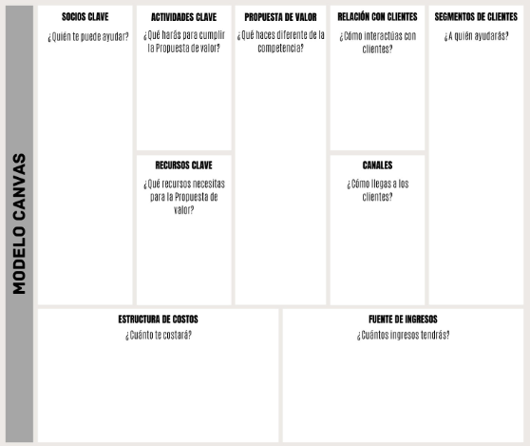

-We fill in the requested fields and relocate the size of the text for a better representation.

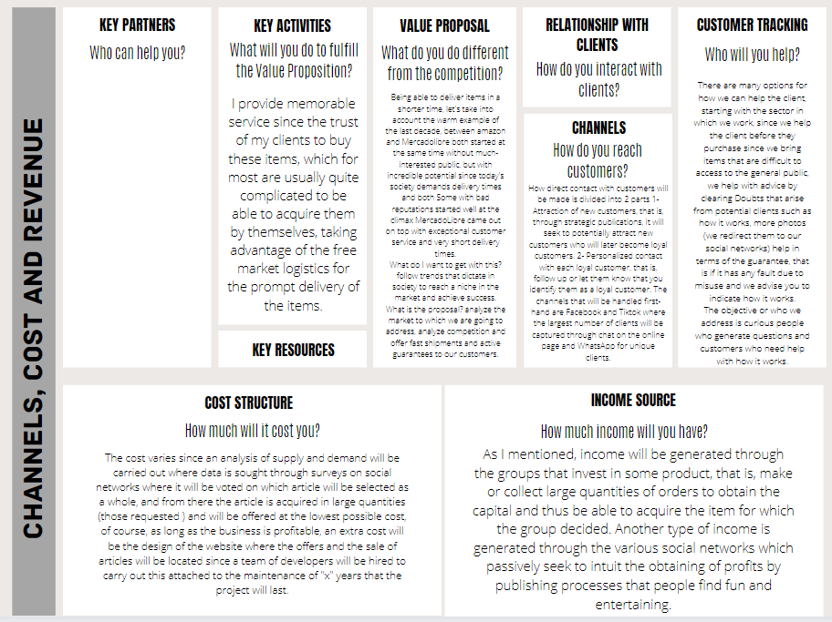

# *Screenshots*

-Channels

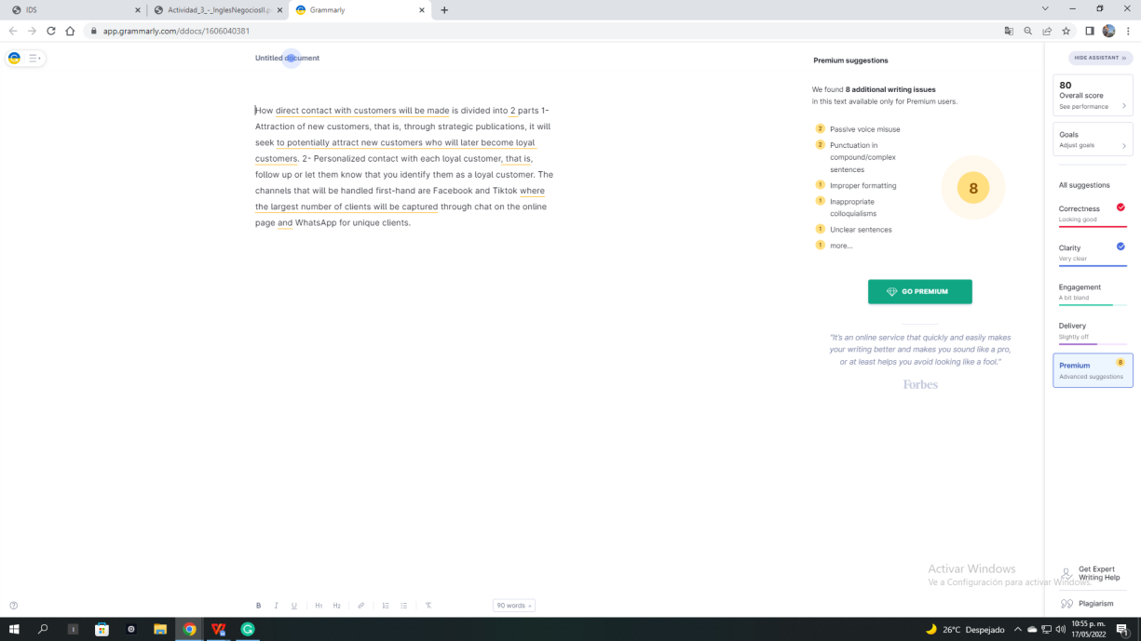

-Cost structure

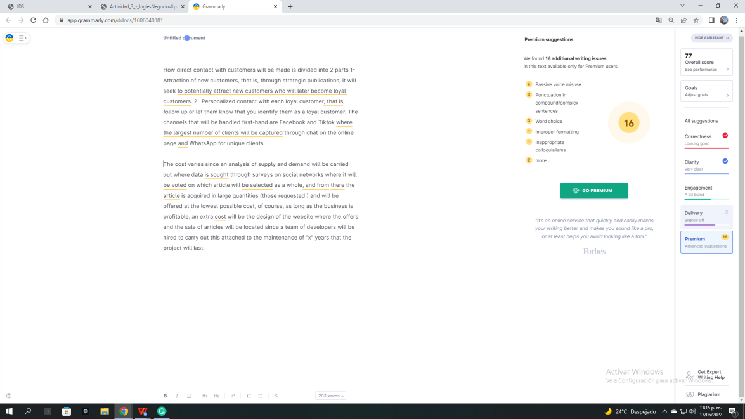

-Income Source

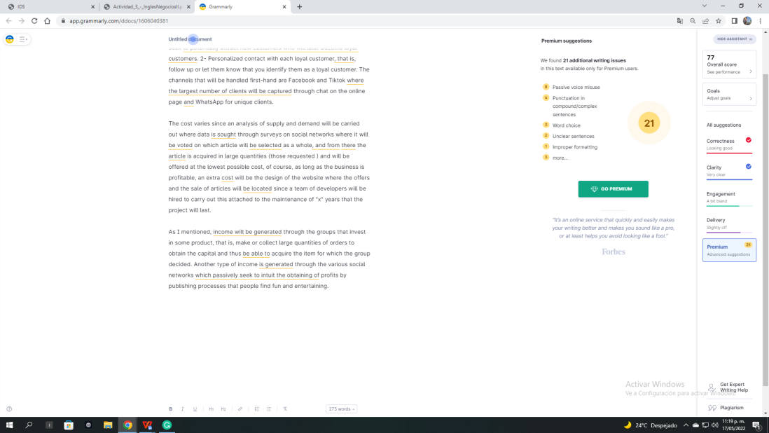

# ***Conclusion***

With this project, it is clear to us that the planning of communication media or channels with which you can be noticed is of the utmost importance since you generate reputation and public recognition, attached to this is the planning of how you plan to sell without the public or clients makes you reach the idea that you have to have a model for capturing new customers to support the business.

Being able to plan how to start with "x" capital resources and gradually recover what was invested and generate notable profits and know how we can help our most loyal customers for a better shopping experience.

# *Bibliography*

Enrique Lopez. (2021). (opens in a new window) Facebook post model canvas for black and white formal business. 2022, by Private Website: <https://www.canva.com/p/templates/EAE7Ecp8BJs-post-de-facebook-model-canvas-for-business-formal-white-and-black/>